Manchester Metropolitan University

2013

Assignment Part 1 – Digital Logic

Precious Osaretin Igbinosun

13129589

Computer Systems Fundamentals

# The 7 Segment Display Truth Table

|  |  |  |  |  |  |  |  |  |  |  |  |  |
| --- | --- | --- | --- | --- | --- | --- | --- | --- | --- | --- | --- | --- |
| DISPLAY | Z | Y | X | W |  | a | b | c | d | e | f | g |
| 0 | 0 | 0 | 0 | 0 |  | 1 | 1 | 1 | 1 | 1 | 1 | 0 |
| 1 | 0 | 0 | 0 | 1 |  | 0 | 1 | 1 | 0 | 0 | 0 | 0 |
| 2 | 0 | 0 | 1 | 0 |  | 1 | 1 | 0 | 1 | 1 | 0 | 1 |
| 3 | 0 | 0 | 1 | 1 |  | 1 | 1 | 1 | 1 | 0 | 0 | 1 |
| 4 | 0 | 1 | 0 | 0 |  | 0 | 1 | 1 | 0 | 0 | 1 | 1 |
| 5 | 0 | 1 | 0 | 1 |  | 1 | 0 | 1 | 1 | 0 | 1 | 1 |
| 6 | 0 | 1 | 1 | 0 |  | 1 | 0 | 1 | 1 | 1 | 1 | 1 |
| 7 | 0 | 1 | 1 | 1 |  | 1 | 1 | 1 | 0 | 0 | 0 | 0 |
| 8 | 1 | 0 | 0 | 0 |  | 1 | 1 | 1 | 1 | 1 | 1 | 1 |
| 9 | 1 | 0 | 0 | 1 |  | 1 | 1 | 1 | 1 | 0 | 1 | 1 |
| A | 1 | 0 | 1 | 0 | UNDEFINED | X | X | X | X | X | X | X |
| B | 1 | 0 | 1 | 1 | UNDEFINED | X | X | X | X | X | X | X |
| C | 1 | 1 | 0 | 0 | UNDEFINED | X | X | X | X | X | X | X |
| D | 1 | 1 | 0 | 1 | UNDEFINED | X | X | X | X | X | X | X |
| E | 1 | 1 | 1 | 0 | UNDEFINED | X | X | X | X | X | X | X |
| F | 1 | 1 | 1 | 1 | UNDEFINED | X | X | X | X | X | X | X |

KEYS

X = UNDEFINED

A – F = UNDEFINED

**Karnaugh Maps for Seven-Segment Display**

|  |  |  |  |  |  |
| --- | --- | --- | --- | --- | --- |
|  | ZY |  |  |  |  |
| XW |  | 00 | 01 | 11 | 10 |
|  | 00 | 1 | 0 | X | 1 |
|  | 01 | 0 | 1 | X | 1 |
|  | 11 | 1 | 1 | X | X |
|  | 10 | 1 | 1 | X | X |
| Output a | | | | | |

|  |  |  |  |  |  |
| --- | --- | --- | --- | --- | --- |
|  | ZY |  |  |  |  |
| XW |  | 00 | 01 | 11 | 10 |
|  | 00 | 1 | 1 | X | 1 |
|  | 01 | 1 | 0 | X | 1 |
|  | 11 | 1 | 1 | X | X |
|  | 10 | 1 | 0 | X | X |
| Output b | | | | | |

|  |  |  |  |  |  |
| --- | --- | --- | --- | --- | --- |
|  | ZY |  |  |  |  |
| XW |  | 00 | 01 | 11 | 10 |
|  | 00 | 1 | 1 | X | 1 |
|  | 01 | 1 | 1 | X | 1 |
|  | 11 | 1 | 1 | X | X |
|  | 10 | 0 | 1 | X | X |
| Output c | | | | | |

|  |  |  |  |  |  |
| --- | --- | --- | --- | --- | --- |
|  | ZY |  |  |  |  |
| XW |  | 00 | 01 | 11 | 10 |
|  | 00 | 1 | 0 | X | 1 |
|  | 01 | 0 | 1 | X | 1 |
|  | 11 | 1 | 0 | X | X |
|  | 10 | 1 | 1 | X | X |
| Output d | | | | | |

|  |  |  |  |  |  |
| --- | --- | --- | --- | --- | --- |
|  | ZY |  |  |  |  |
| XW |  | 00 | 01 | 11 | 10 |
|  | 00 | 0 | 1 | X | 1 |
|  | 01 | 0 | 1 | X | 1 |
|  | 11 | 1 | 0 | X | X |
|  | 10 | 1 | 1 | X | X |
| Output e | | | | | |

|  |  |  |  |  |  |
| --- | --- | --- | --- | --- | --- |
|  | ZY |  |  |  |  |
| XW |  | 00 | 01 | 11 | 10 |
|  | 00 | 1 | 1 | X | 1 |
|  | 01 | 0 | 1 | X | 1 |
|  | 11 | 0 | 0 | X | X |
|  | 10 | 0 | 1 | X | X |
| Output f | | | | | |

|  |  |  |  |  |  |
| --- | --- | --- | --- | --- | --- |
|  | ZY |  |  |  |  |
| XW |  | 00 | 01 | 11 | 10 |
|  | 00 | 0 | 1 | X | 1 |
|  | 01 | 0 | 1 | X | 1 |
|  | 11 | 1 | 0 | X | X |
|  | 10 | 1 | 1 | X | X |
| Output g | | | | | |

# The Simplified Sum of Product Expressions for Seven Segment Circuit the Use of Karnaugh Map

The karnaugh map is a form of Boolean simplification. The functions from the truth table are used to plot the map and then putting the functions into possible groups of 1, 2, 4, 8 or 16.

$$a=w'∙y'+w∙y+x+z$$

$$b=w'∙x'+x∙w+y'$$

$$c=w+x'+y$$

$$d=w^{'}∙y^{'}+x∙y^{'}+w^{'}∙x+w∙x^{'}∙y+z$$

$$e=w^{'}∙y^{'}+w'∙x$$

$$f=w^{'}∙x^{'}+x^{'}∙y+w^{'}∙y+z$$

$$g=x∙y^{'}+x^{'}∙y+w^{'}∙y+z$$

Display = 0

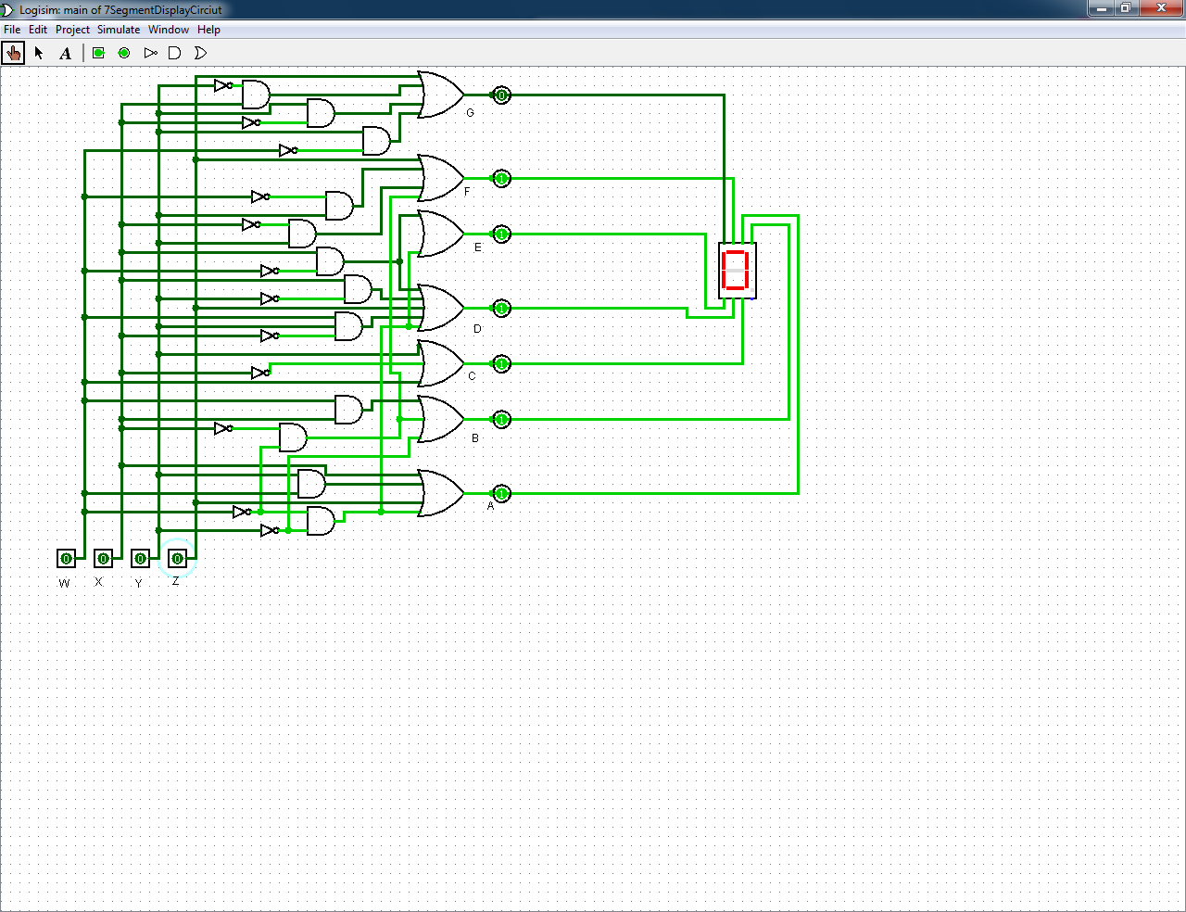

Display = 1

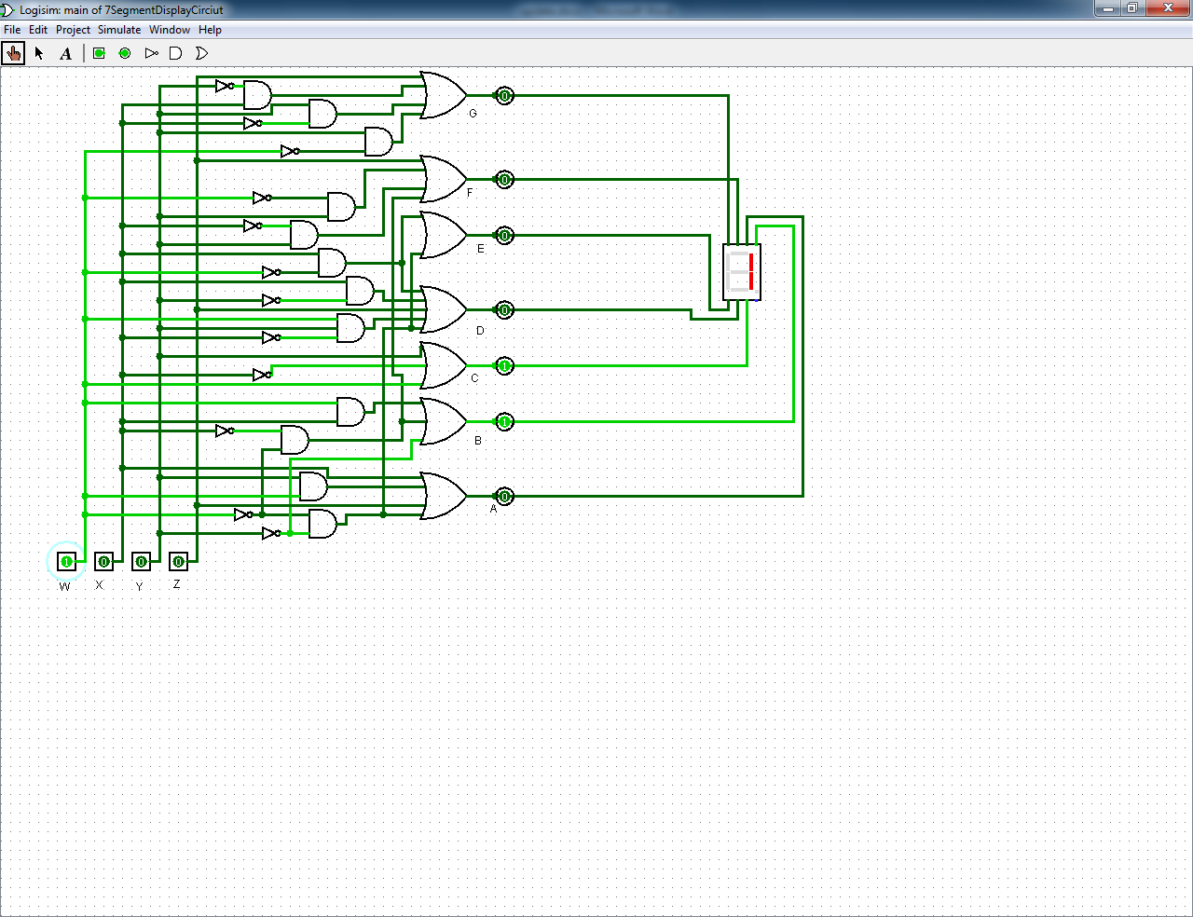

Display = 2

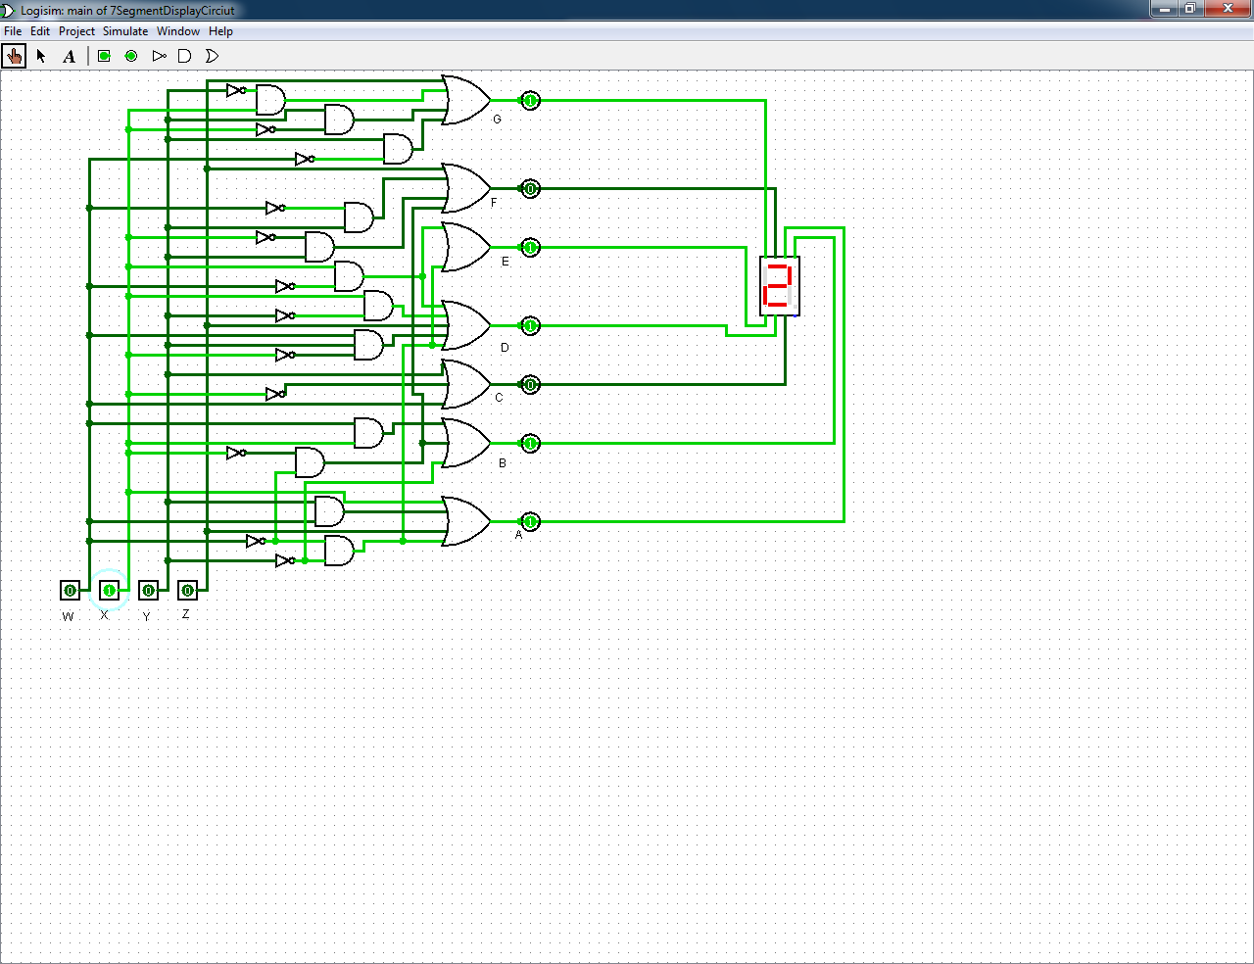

Display = 3

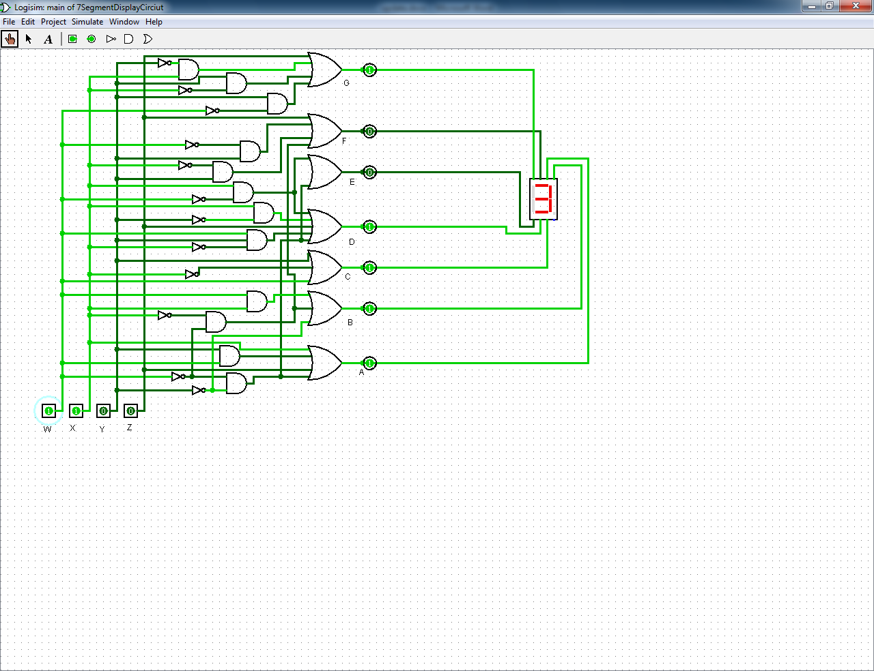

Display = 4

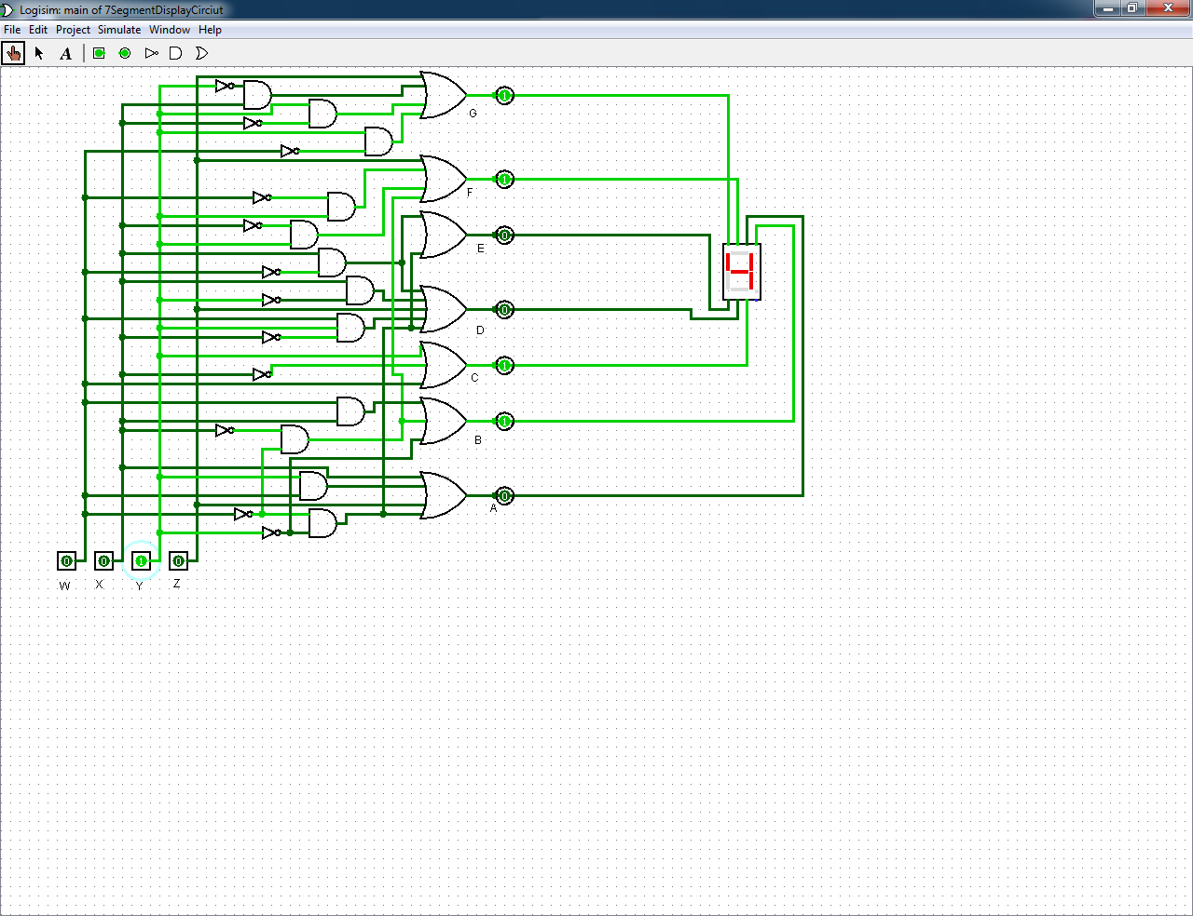

Display = 5

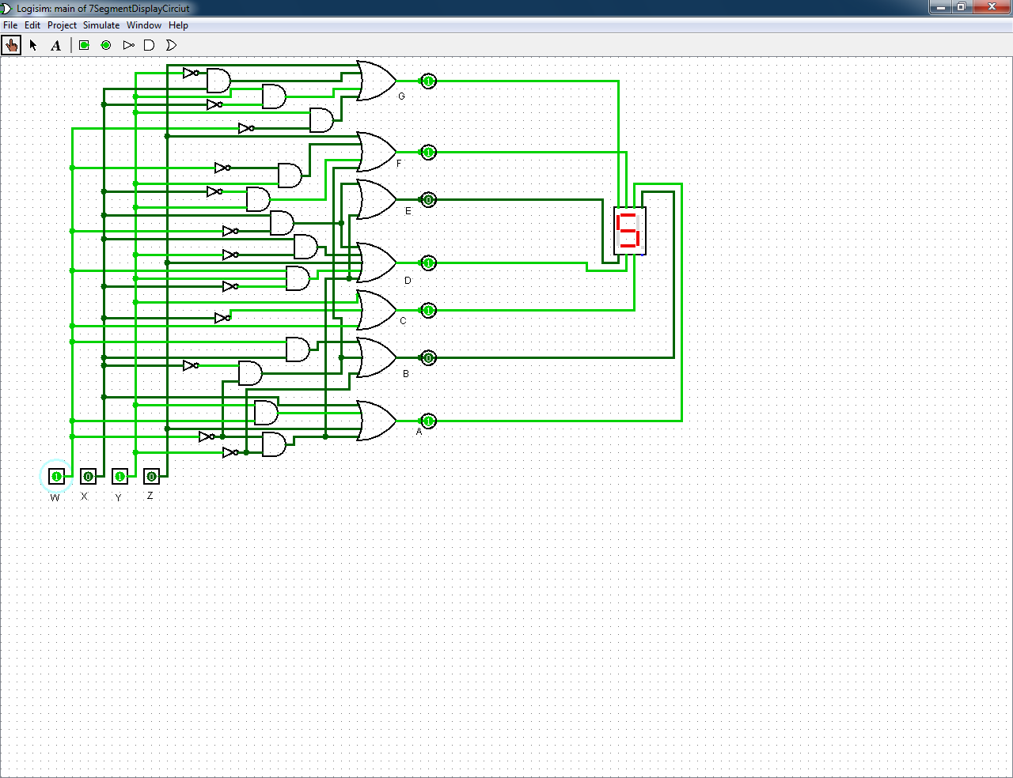

Display = 6

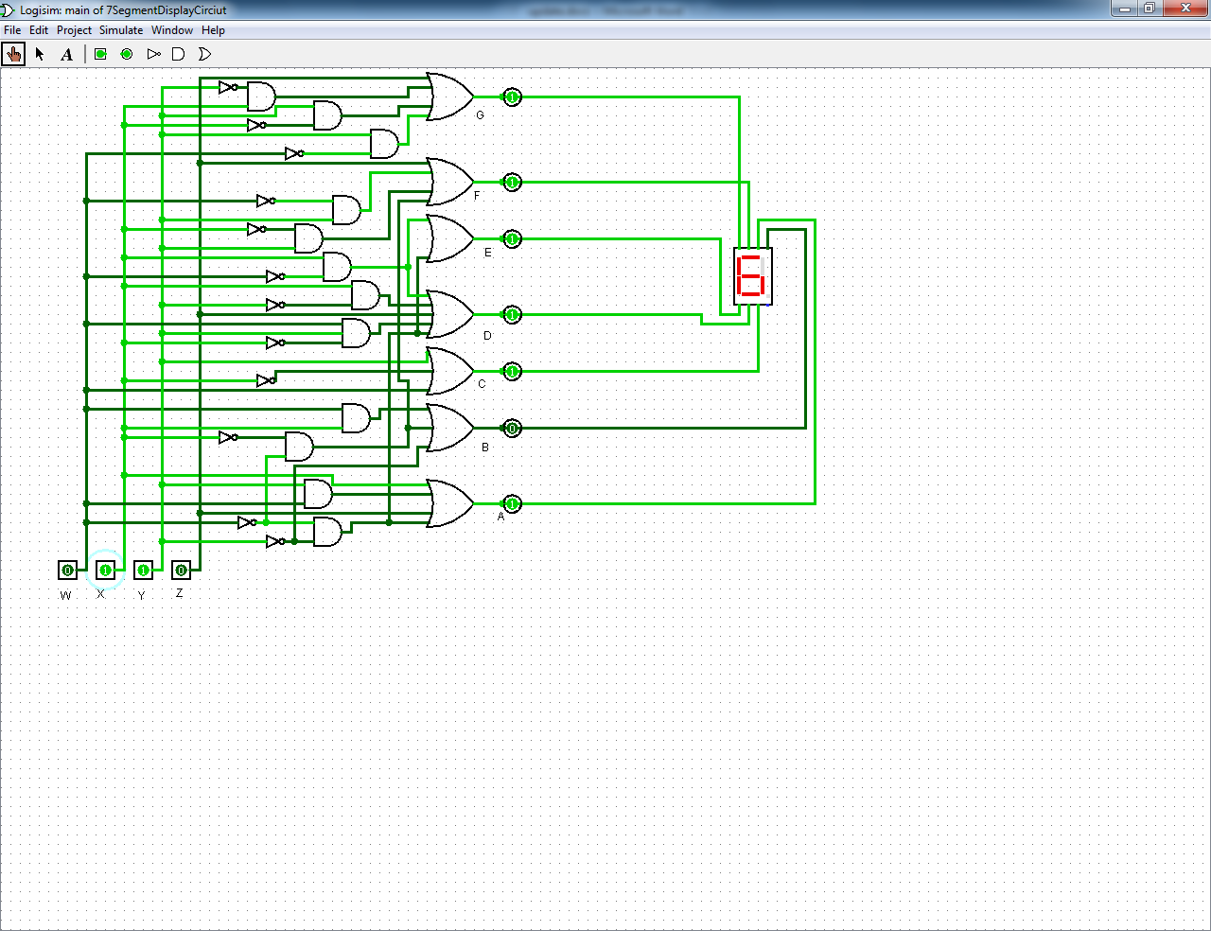

Display = 7

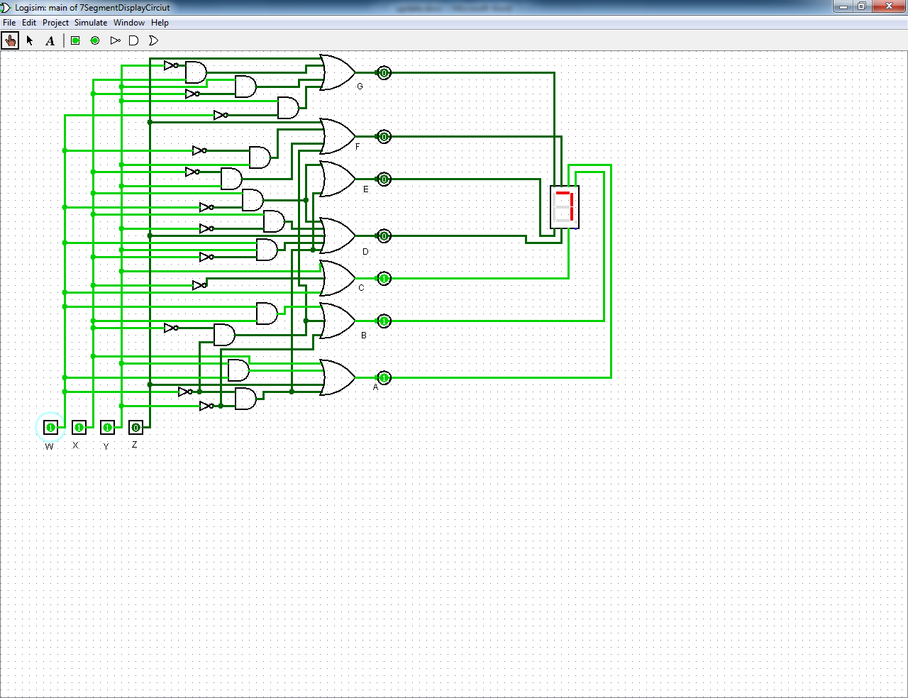

Display = 8

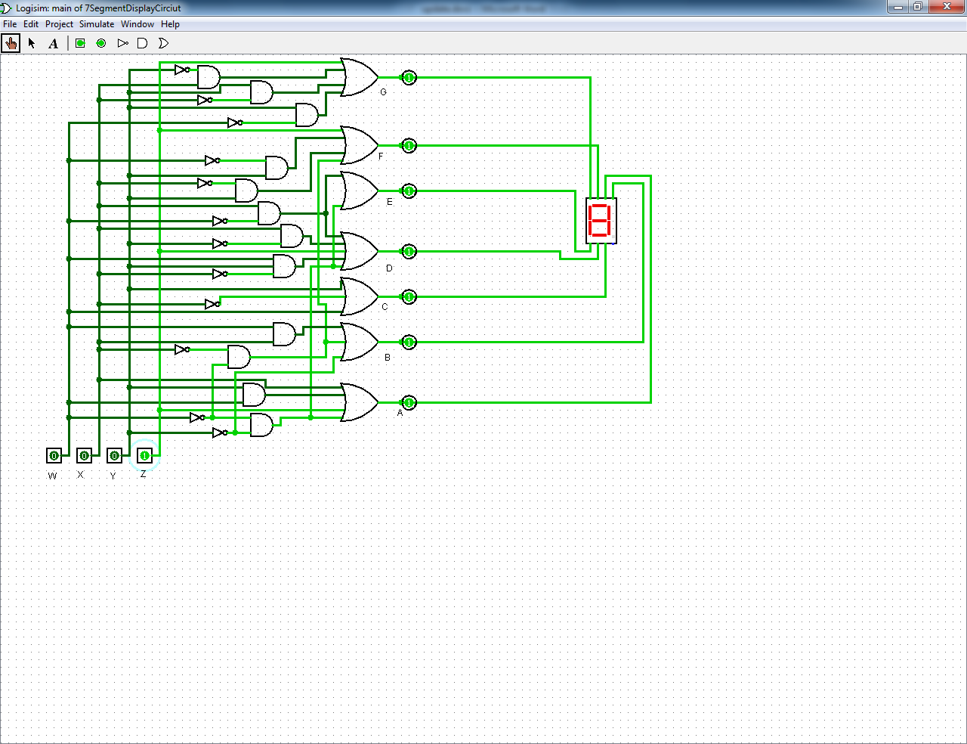

Display = 9

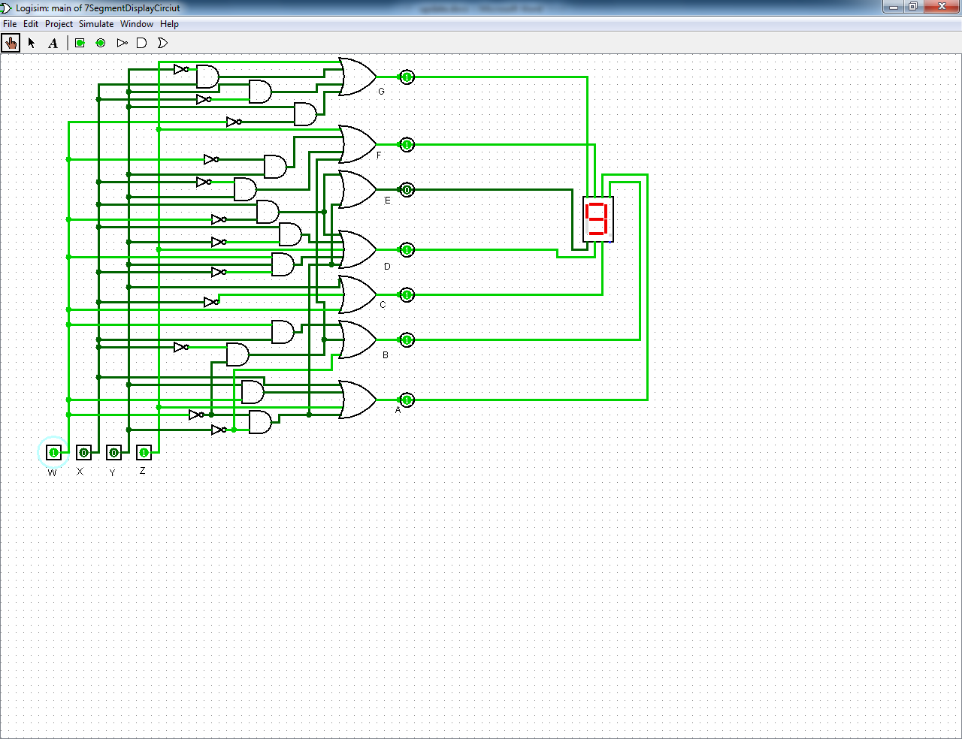

# Reference

Alan Clements. (2006). Gates, circuits, and combinational logic. In: Principles of Computer Hardware. 4th ed. United States: Oxford University Press. p69-87.